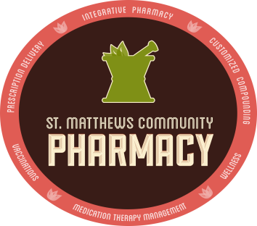
St. Matthews Specialty Pharmacy

Local and Personal
p 844-690-4462| f 844-524-HOPE(4673)

PROVIDER SATISFACTION SURVEY

Dear Provider,

It is our desire to provide you with the best quality services available. In order to help us maintain our high standards, please take a few moments to tell us how we are doing.

- Do you currently refer patients to St. Matthews Specialty Pharmacy?

- Please rate St. Matthews Specialty Pharmacy in terms of:

Excellent Good Fair Poor

The overall ease of the referral process

The courtesy/helpfulness of our staff

Our ability to partner with your practice to
manage patient drug therapy

The clinical skills of our pharmacists

Our ability to facilitate prior authorizations

Our ability to notify you about any issues
your patients expressed regarding their prescriptions

Our ability to achieve financial assistance for your patients

Your patient’s comments about our pharmacy

The responsiveness of our office staff to your requests

Saving your practice money by redeployment of staff

Our ability to improve patient outcomes for you

- Please indicate your level of agreement regarding your partnership with St. Matthews Specialty Pharmacy:

Strongly Strongly
Agree Agree Undecided Disagree Disagree

Improve patient adherence to drug therapy

Saves time for staff

Saves time for the physician

Provides your patients with a better
care experience

Brings value to your practice

Promotes local business

- What is your overall rating of our service?

Excellent Very Good Good Fair Poor

- How can we improve our services to you and your patients?

Thank you for your support!

________________________________ ______________
Signature Date

11/15/2018

