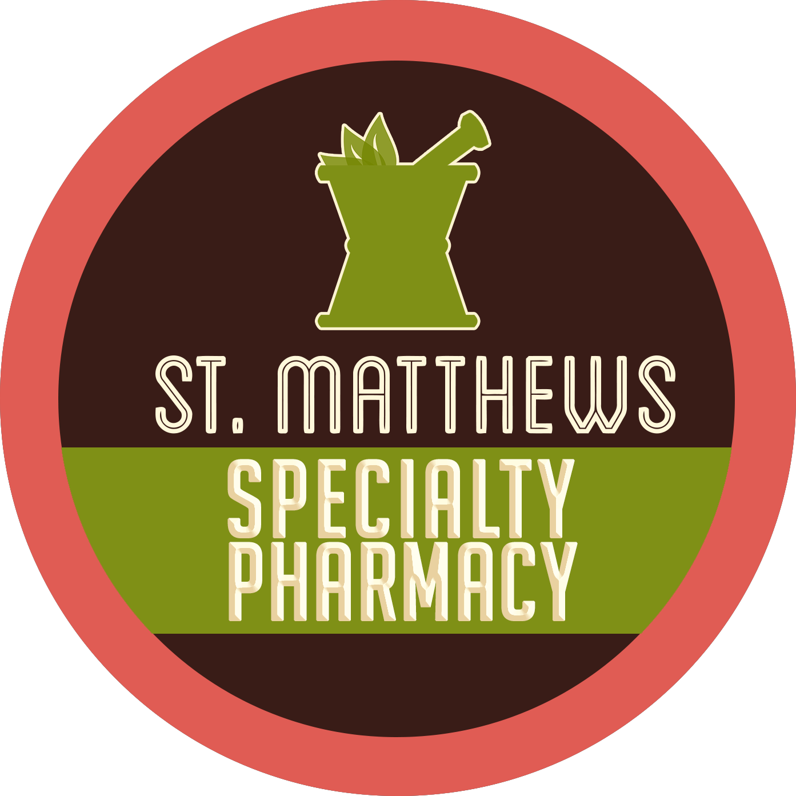St. Matthews Specialty Pharmacy
Local and Personal
p 844-690-4462| f 844-524-HOPE(4673)

PATIENT SATISFACTION SURVEY

Dear Patient, Date:

It is our desire to provide you with the best quality services available. In order to help us maintain our high standards, take a few moments to tell us how we are doing. Please complete and mail it back to us. Thank you.

The medications (and supplies if applicable) were delivered on time | ❑ YES | ❑ NO
The medications (and supplies if applicable) were dispensed correctly | ❑ YES | ❑ NO
Training and consultations were effective in educating me or my caregiver on my service / care and /or therapy | ❑ YES | ❑ NO
Educational materials and instructions were adequate to educate me or my caregiver on the product(s) | ❑ YES | ❑ NO
The staff was courteous and helpful | ❑ YES | ❑ NO
My financial responsibilities were explained to me | ❑ YES | ❑ NO
I receive advice or help when needed | ❑ YES | ❑ NO
The services provided made a positive impact on the outcome of my care and/or therapy | ❑ YES | ❑ NO
I would recommend your service to my friends and family | ❑ YES | ❑ NO
The services provided met my needs and expectations | ❑ YES | ❑ NO

How likely is it that you would use our specialty services to fill your future prescription needs? (please circle) Not at all likely Extremely Likely
0 1 2 3 4 5 6 7 8 9 10

How likely is it that you would recommend St. Matthews Specialty Pharmacy services to a friend or colleague?
Not at all likely Extremely Likely
0 1 2 3 4 5 6 7 8 9 10

COMMENTS (OPTIONAL):

Signature (optional):

Rev. 5/10/2019

www.StMatthewsRx.com

